**CHAPTER 2**

**DESIGN AND DEVELOPMENT**

**2.1 METHODOLOGY**

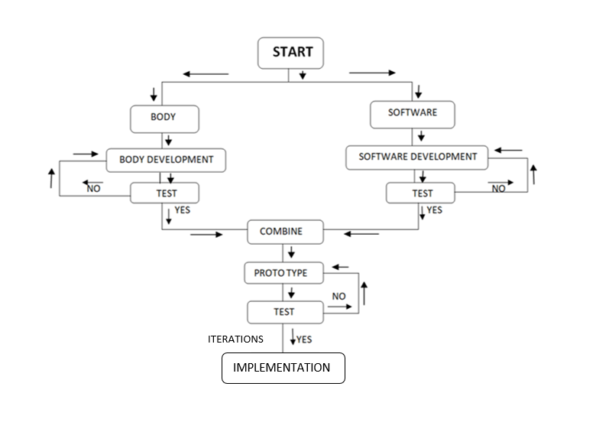The methodology flow is shown in the fig 2.1. It is divided into several steps so that it is easy to analyse and develop the robot.

Fig 2.1 Flow-chart of robot development

Developing a robot involves various disciplines such as electro-mechanics devices and software for operations as shown in the fig 2.1 below. To ensure efficient design, construction, and implementation, the development method of the robot is divided into two parts as discussed below.

1. Body development
2. Software development

This division leads to the proper development from the head to the bottom-wheeled system and the software integration. At first, the body is developed and tested, and next the software is developed and combined with it and examined. The outcome of the test is positive with no intervention or any iterations needed, the prototype is ready and if not re-checking all the connections, integration, and finding out the trouble, resolve it and the same steps are continued.

**2.1.1 Body Development**

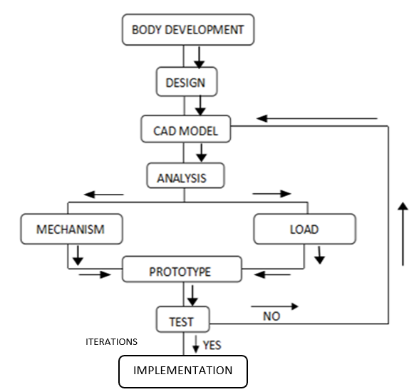 The body's development flow is from the design of the body to test/implementation which includes the head to the base with the wheel motion system. As Fig 2.2 shows the flow includes designing the parts in CAD. Analysing it with all the mechanisms and load it holds, next testing is carried out. If some iterations are required, are updated and again tested.

Fig 2.2 Flow chart of Body development

Firstly, the head part is considered which 3D printed and fixed with nuts and bolts is. It includes an eye mechanism and the neck part has a rotation controlled by servomotors. The torso [mid part] of the robot is made of fiber using FRP. It has arms with 5 degrees of freedom and a gripper mechanism to pick an object and provide service. The lower half of the body is designed with an extension in such a way that it is helpful to carry the objects easily on it. The lower frame is made up of mild steel and covered with wood which has a trapezoidal look. The total lower half and upper half of the body stand on the strong base which is the four-wheeled system with motors providing motion and electronics providing the power. The mentioned mechanisms are tested and if iterations are needed then done and again tested.

**2.1.2 Software Development:**

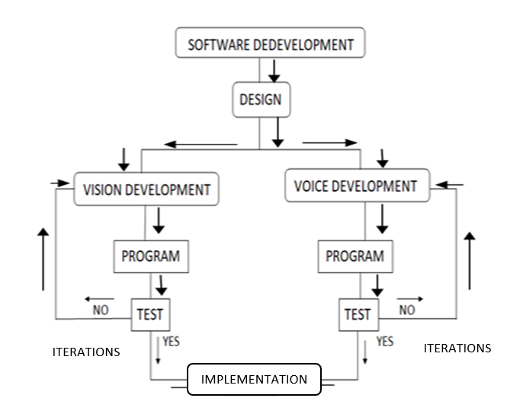Software development is an essential part of the project to control the robot's motion and functions. As shown in the Fig [2.3] software development has multiple steps involved where the vision and voice development are divided separately. The programming is done for the application development for the motion control, eye movement control and hand movement.

Fig 2.3 Software development

The software development includes the application built for the control of the robot’s movement and the voice assistant. The application controls the forward, backward, and turning motion of the robot and at what speed it has to move. The voice assistant helps to interact with humans. It answers the pre-commands that are already coded in it. Later the software is tested and blended with hardware and make it work in real. The microphone captures the voice and processes and converts it to text, looks for the match in the pre-coded commands, and if matches are found the corresponding response or actions are provided.

* 1. **DESIGN OF ROBOT**

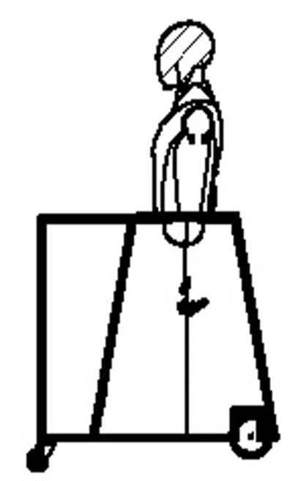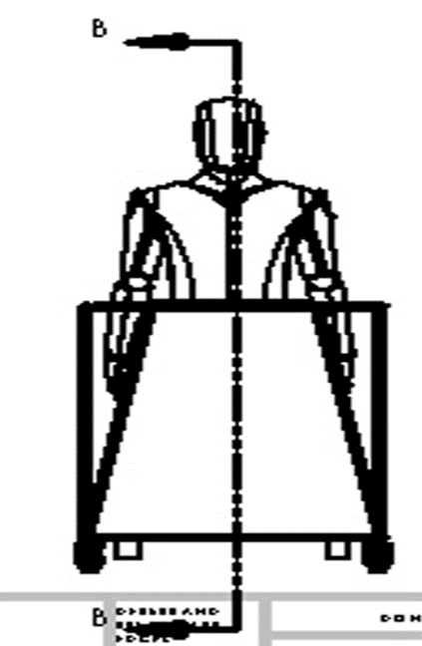A computer-aided design, or CAD, model is a computer-generated digital representation of a system or item utilizing specialized software. Before actual prototype or production, CAD models are widely used in the engineering, architectural, industrial, and product design industries to visualize, simulate, and analyze concepts. Engineers and designers can swiftly iterate, make design revisions, and assess performance aspects like strength or thermal properties because to the precise geometric information contained in these models, which includes dimensions, forms, and material properties. From straightforward 2D sketches to intricate 3D models, CAD models offer a flexible toolkit for ideation, design improvement, and teamwork across the whole product development lifecycle.

Fig 2.4 Front view Fig 2.5 Side view

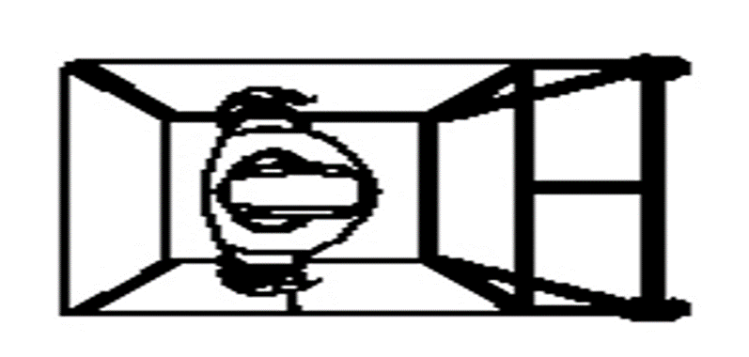

Fig 2.6 Top view

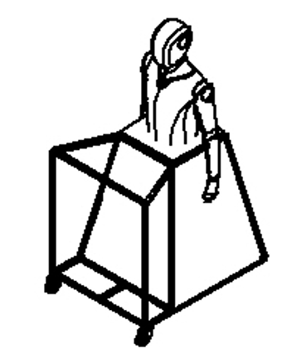

Fig 2.7 Isometric View

**2.3 DEVELOPMENT OF HUMANOID ROBOT BODY AND MECHANISM**

The robot body component and mechanism are divided into several parts like head, hand, eye, and lower body. The mechanism is also divided by their body parts' movement and specific tasks and functions as shown below.

**Table 2.1 Table of body robot body components.**

|  |  |  |  |  |
| --- | --- | --- | --- | --- |
| **Sl. No.** | **Component Name** | **Number of components** | **Instrument Used** | **Material Used** |
| 1 | Head (Neck) | 1 | Servo Motors | PLA |
| 2 | Eyes | 2 | Servo Motors | PLA |
| 3 | Arms | 2 | Servo Motors | PLA |
| 4 | Lower body moving | 2 | wiper motor | MS Rods, plywood |

**2.3.1 Head part:**

Humanoid robots are complex systems that are characterized by high functional and spatial integration. The design of such systems is a challenge for designers and is often a long and iterative process.

The head of the robot body was discretized in several parts to achieve the shape of the head. The dimensions deduced from human skeletal data are used to create a model of our Humanoid robot in Computer Aided Design software. Modelling can be done in two different ways. Mathematical modelling formulates a governing equation for the physical event while Software modelling is to represent the physical event to the dimensions in a computer-aided design software. Moreover, the software might not have existed if there was no mathematical modelling done for an event, the software just remembers the mathematical modelling done for a similar physical event and interpolates that to the new or similar physical events. Mathematical modelling is a bit tedious and requires sufficient knowledge while the latter is a bit easier and less time-consuming. Fabrication Based on the analysis, the humanoid robot is fabricated to bring it live onto the earth. Looking in to this the material selection for the project is decided based on the price and mechanical property of the material The fabrication part is divided into mechanical aspects, electrical and electronic aspects, and computer programming.

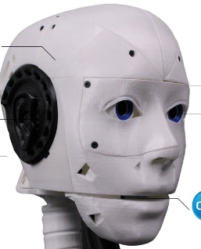 The head part was divided into small pieces parts because it can easily fit and for internal eye mechanism setup can fit properly. The face design take from our source online so that easy and precision of the face dimensions. The whole head part is built in a 3D printed machine. The material used for 3D printed heads is PLA which has good mechanical properties like durability, and lightweight material and also reduces the weight of the body. It also produces less noise while rotating and movement of head of the robot. Due to the 3D printed part surface finish has good accuracy.

Fig 2.8 Head of the Robot [36]

* + 1. **Eye part:**

For the robot eye mechanism movement, we are using dual servo motors for each left and right eye. Its separate servo controls horizontal axis and vertical axis rotations, to act like a real human eye. The servo allows to the eye movement for some vertical and horizontal specific range of directions and it integrate with a small camera in that eye ball its enable for surrounding view. Another approach is to use an eye mechanism in a humanoid robot, where the rotation of the eyeball is transformed into displacement in a two-dimensional coordinate plane through simple devices. This mechanism allows for synchronous rotation of the two eyeballs in any direction, at any angle, and at any speed.

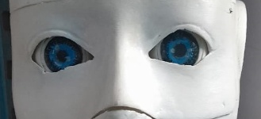

Fig 2.9 Eye and Cheek

**2.3.3 Chest parts:**

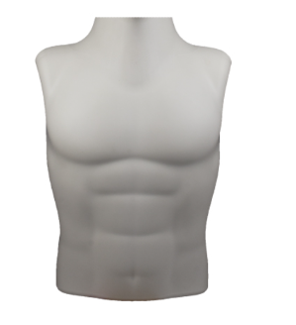This is the most asthmatic attraction part of the humanoid robot, here the part is extracted from the toy dummy which is manufactured using the FRP method so that all the internal components and mechanisms, of the body, can be accumulated inside the body. The mannequins (body) are made of a fabric material it is a hard material with good strength. It can hold arm weight and it is waterproof the environment can damage the body. The body gives a similar look to the human body. It can made at a low cost.

Fig 2.10 Middle part of the robot body [37]

* 1. **Mechanism of the Humanoid Robot:**

Built to resemble us, humanoid robots embody both human form and function. Their skeletons are crafted from light yet super-strong materials, while joints with different movement options grant them lifelike mobility. Electric motors, powerful fluids, or compressed air act as their muscles, fuelled by batteries, external cords, or even built-in generators.

**2.4.1 Eye Mechanism:**

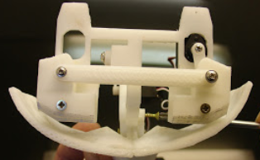 For the robot eye mechanism movement, we are using dual servo motors for each left and right eye. Its separate servo controls horizontal axis and vertical axis rotations, to act like a real human eye. The servo allows to eye movement for some vertical and horizontal specific range of directions and it integrates with a small camera in that eyeball its enable for surrounding view. Another approach is to use an eye mechanism in a humanoid robot, where the rotation of the eyeball is transformed into displacement in a two-dimensional coordinate plane through simple devices. This mechanism allows for synchronous rotation of the two eyeballs in any direction, at any angle, and at any speed.

Fig 2.11 Eye mechanism

**2.4.2 Head (Neck) Mechanism:**

The robot neck mechanism crucial role. It has a single servo motor which provides the robot the ability to move its head in various directions like humans and help to see the surrounding environment for the action by tilting its head left and right direction to expand the view. The series connected joints like a human spine which support the neck and head for rotating in desired directions. The servo is connected to a gear for controlling a rotation speed head. Due to the light weight of the 3D printed head material, it reduces the weight of the servo motor and ensures the balance of the moving head. And less weight of the head mechanism prevents self-injuring itself.

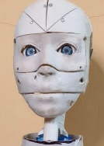

Fig 2.12 Head mechanism

**2.4.3 Hand mechanism:**

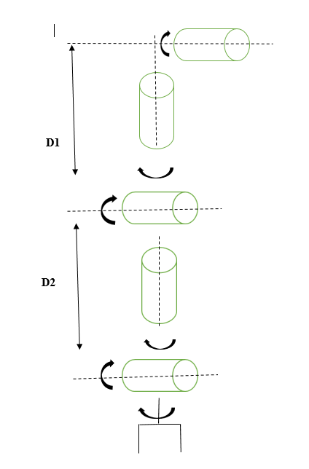 To act like human arms the way humanoid robots should a modular to design and efficient degree of freedom so that can it mimic human arm and hand motions. To perform motions like human arms it should have 7 DOF and 7 DOF out of 5 DOF for only arm.

Fig 2.13Model for the Arm to get the trajectory [38]

The human upper limb to shoulder hand the weight of the arm it could be 1.4 kg and the length measures 60 cm from shoulder to wrist with dimensions and proportions similar to adult human hands. The arm has 5 independent DOFs, each of them actuated by a dedicated servo motor. Each arm joints have different rotation and linear motions. Due to the human arm-like structure, the angle or joint range movement is also limited.

**2.4.4 Lower Body**

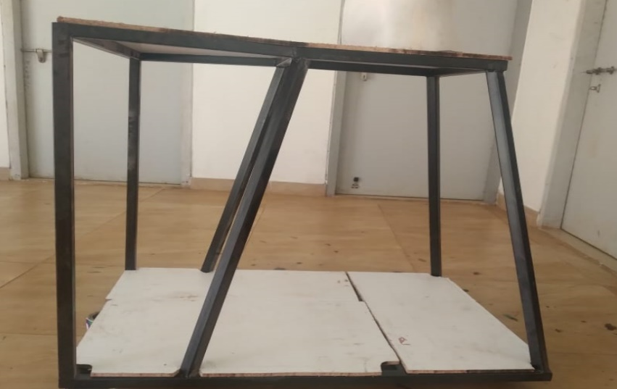 The lower part of the robot body is a frame that has the most strength. It is framed using mild steel. Mild steel has very good mechanical properties such as high impact strength, high tensile strength, ductility, and more. The main property the project has concentrated on and considered is its great weld ability and flexibility by which it has been shaped with ease accordingly.

Fig 2.14 Lower Body frame

The lower body of the robot is given the trapezoidal shape planned to provide support for the upper body stand. It is a tapering trapezoidal prism wider at the bottom. It has an extension on which the load is carried. The frame is covered by the wood. As it is a lightweight dry material. Properties that make it remarkable are such as its strength, toughness, its wide availability and it is inexpensive as plywood is collected from the remains in the college. The lower body is also a holonomic structure. The battery from the base, any connections from sensors to the board, or any electronic components adopted in the robot can be placed inside this lower body.

**2.5 Movement of complete robots**

The generation of motion for humanoid robots is quite different from that of standard robots because of the large number of joints, coupling between joints, and redundancies. Our basic assumption is that humanoid robot kinematics can be embedded into human body kinematics. The humanoid’s kinematics do not need to reproduce every aspect of human kinematics (indeed, this would be impossible), but should reproduce some properties of the human body. The principles governing whole-body coordination in humans are far from being understood and implementations on complex systems, such as humanoids, are missing, especially besides walking. The balancing with multiple rigid contacts, the robot's upper body standing and balancing with supported by a lower body rigid table-like structure. The robot's hands intend to reach for an object on the table the robot will recognize that the distance is sufficiently far away, and the task cannot be achieved without compromising the balance. The head and eye have a combined motion like the human example when the human eye sees in any direction the head rotates that direction with the eye. The lower body has a rear wiper motor which is connected to the wheel and provides high-power rotational motion and the front wheel are caster wheel that guides the robot in the desired direction.